JOMO KENYATTA UNIVERSITY OF AGRICULTURE AND TECHNOLOGY

INSTITUTE OF COMPUTER SCIENCE AND INFORMATION TECHNOLOGY

INFORMATION TECHNOLOGY DEPARMENT

A project report submitted in partial fulfillment of the requirements for the Degree of Bachelor of Science in Information Technology.

SYSTEM ANALYSIS & DESIGN

**MUCHERU NYAMBURA ALICE**

**BIT-001-2250/2010**

JANUARY 2014

Table of Contents

3.1 SYSTEM ANALYSIS AND DESIGN 4

3.1.1 Introduction. 4

3.2METHODOLOGY 6

3.2.1System analysis 6

3.2.2 System design 6

3.2.3 Object design 6

3.2.4 Implementation 6

3.2.5 Advantages of Object Oriented Methodology 7

Figure 3: object oriented analysis and design 7

3.3FEASIBILITY STUDY 8

3.3.1 Technical Feasibility 8

3.3.2 Economic Feasibility 9

3.3.2.1COST BENEFITS ANALYSIS 9

3.3.3. Operational Feasibility 9

3.3.4 Social Feasibility 10

3.3.5 Legal Feasibility 10

3.4Data collection tools . 11

3.4.1Observation: 11

3.4.2Questionnaires 11

A sample of questionnaire prepared 12

3.4.3Interviews: 12

Report from the questionnaire & interviews 13

3.5FUNCTIONAL REQUIREMENTS SPECIFICATION 16

3.6 N0N-FUNCTIONAL REQUIREMENTS SPECIFICATION 16

3.6.0EXECUTION QUALITIES 16

3.6.0.1SECURITY 16

3.6.0.2REUSABILITY 16

3.6.0.3 ACCESIBILITY 16

CHAPTER FOUR 17

4.0System Design 17

4.1Logical design 17

4.1.1Current system (Sequence) 17

4.1.1.1Proposed System 18

4.1.2Conceptual Entity Relational model 18

4.1.3Use case model 20

4.1.4Class diagram 22

4.1.5Final ERD and database schema 23

4.2PHYSICAL DESIGN 23

4.2.1 Database schema 23

5.0 Input/output screen designs 24

6.0 Implementation & Testing 29

6.1 Description of development Environment/tools 29

Programming tools 29

Database tools 29

7.0 Sample Test Data & Error Handling 29

7.1 Wrong Password Inputs 29

7.2 Form Validate 30

7.3Appendices 32

**CHAPTER 3**

# SYSTEM ANALYSIS AND DESIGN

## 3.1.1 Introduction.

Analysis is a step in system development that is concerned with detailed investigation by the system developer, by first studying the existing system, then using the information gathered to define the requirements of the new system.

System analysis or requirement analysis is the problem that the organization will try to solve in the software system. It consists of defining the problem identifying, specifying the solution and identifying the information requirement that must be met by the software system solution.

**Why Analysis?**

Analysis being a process for identifying and solving problems, it involves breaking the proposed system down into its parts so that the whole may be understood. Going ahead to design phase without deeply analyzing and clearly understanding the system could lead to serious errors. Again, it’s worth emphasizing that a mistake or missed requirement from the analysis phase may cost much more money to fix later than if it had been caught in the analysis phase.

Analysis is done with intent of improving the system through better procedures and methods. When the system is investigated, analysis will find more weaknesses in it. Moreover, analysis is also done to develop information systems to meet new information or operational needs.

# 3.2METHODOLOGY

Object oriented analysis and design methodology takes objects as its basis and for the proposed system to be developed using java platform, it has to be observed and requirements defined. Once this is done, the objects in the system are identified through object modeling and their interrelationships. The coding of the system begins as it follows a sequential process of system designing approach. The basic steps of object oriented analysis and design are as follows;

## 3.2.1System analysis

This phase involves interacting with user of the system to find out the user requirements and carryout analysis of the system to understand the functions. Based on system study, I will prepare models of the desired system. This model will be purely based on what the system requires to do as the system is made up of a set of interaction objects like the use of use cases and data flow diagram.

### 3.2.2 System design

In this stage the overall architecture of the desired system will be decided. The system will be organized as a set of subsystem interacting with each other.

### 3.2.3 Object design

Under object design, the details of system analysis and design are implemented. The objects that I will have identified in the system design are constructed, and these objects will be decided and data structures are defined and also interrelationships between objects are constructed.

### 3.2.4 Implementation

During this phase, the class objects and the interrelationships of these classes will be translated actually coded using java programming language. The databases will be made and the complete system will be given a functional shape.

### 3.2.5 Advantages of Object Oriented Methodology

* Object Oriented Methodology closely represents the problem domain. Because of this, it is easier to produce and understand designs.
* The objects in the system are immune to requirement changes. Therefore, allows changes more easily.
* Object Oriented Methodology designs encourage more re-use. New applications can use the existing modules, thereby reduces the development cost and cycle time.
* Object Oriented Methodology approach is more natural. It provides nice structures for thinking and abstracting and leads to modular design.

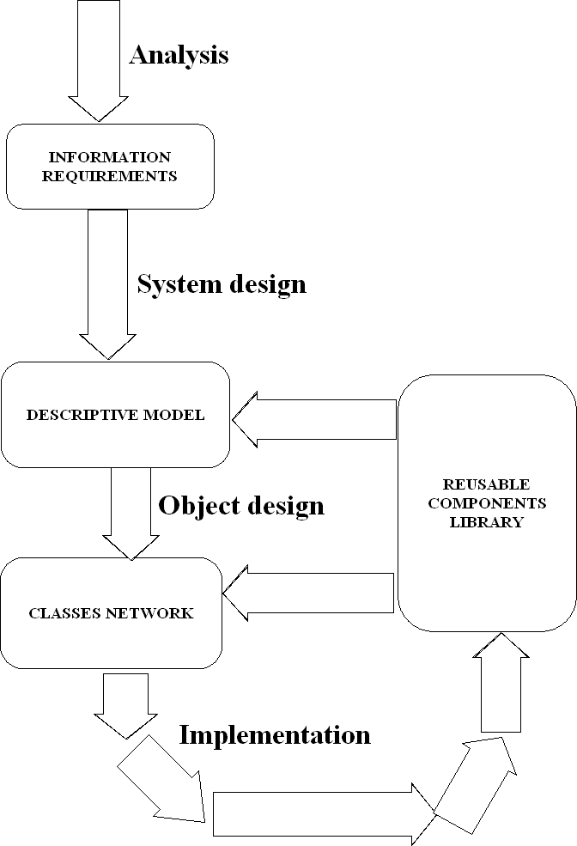

#### Figure 3: object oriented analysis and design

# 3.3FEASIBILITY STUDY

This is a study aimed at finding out whether the system is viable or not, carried out to make sure that the new system would be efficient to the clinic once implemented. It is concerned with analyzing the available technology, system operation and use of the available funds for the project. The feasibility study was done during several visitations to the clinic to find out how the office carried out its operations. During the study, it was realized that the clinic faced several problems with the current system.

A feasibility study was carried out on the following areas in order to determine the viability of the project.

## 3.3.1 Technical Feasibility

During the research, it was noted that there was lack of enough hardware, software and skilled personnel to operate and maintain the system. It was also noted that the available software and hardware devices were outdated. The management was therefore required to purchase new computer systems and the staff would be trained freely on computer skills in order to be in a position to operate them.

Figure 4 Chart 2: Staff’s Response on Technical Viability of the new system

With majority of the staff approving the system as technically viable, its development was approved.

## 3.3.2 Economic Feasibility

This was also carried out by comparing the cost of developing, operating and maintaining the proposed system against rate of returns to find out whether the costs to be incurred in the development of the new system would be justified by the benefits.

## 3.3.2.1COST BENEFITS ANALYSIS

* To reduce record costs and office operational costs.
* Increasing processing efficiency thus improving professionalism
* Leading to client satisfaction and goodwill.

## 3.3.3. Operational Feasibility

This feasibility study method was carried out to check whether the new system conforms to the normal ways that the clinic ran their work and ascertain whether the system was user friendly hence acceptable to the new users. The new system is just an improvement of the old system into a new format that is automated thus conforming to the normal operations of the organization.

With all the advantages coming with the new system, 80% of the staff members believed that the system would be viable operationally, 13% felt the opposite while only 7% of the members were not sure. Given that a good number of the staff members were positive that a new system would conform to the normal way the clinic ran their work, the operational study was deemed viable.

## 3.3.4 Social Feasibility

This was based on the acceptability of the system by users. It dealt with the willingness and ability of the staff to accept the proposed system. A number of the staff members are computer literate except for a few who feared that since they did not have computer skills, the introduction of a new system would displace them. Some of these employees were relieved by the fact that the organization planned to offer a free training to its staff on the new system to enable them fully operate the new system without any difficulties. The staff was impressed by the information of the introduction of a new system. They readily welcomed the fact that a free training was in store for them and that the new system would not only be easy to operate but would ease their work a big deal.

## 3.3.5 Legal Feasibility

This study method was carried out to find out whether the new system abides by the laws, rules and regulations, which should not be violated. The possibility of displacing some of the workers posed a great risk if they decided to file cases against the organization; however, this relied on what legal factors had to be imposed. Nevertheless, the new system was granted a go ahead.

# 3.4Data collection tools.

## 3.4.1Observation:

Observation was used as a data collection tool in the health clinic. There was preparation to visit the employees.

*Advantages of observation*

* Data gathered were highly reliable
* I was able to see exactly what is being done
* Its relatively inexpensive
* Complex operations that are not easily explainable can be understood through observation.

**Disadvantages of observation.**

* People may feel uncomfortable when being observed
* Some systems activities may take place at odd times causing a scheduling inconveniencies for the system analyst.
* The tasks being observed are subject to various types of interruptions.

## 3.4.2Questionnaires

Questionnaire was prepared on a form for the employees. The questions were well formulated according to the system in focus.

**Advantages of questionnaires**

* It is free from interviewer distortion and error
* They save time in data collection
* They avoid biasness
* Data can be collected from a large sample.
* Questionnaires allow individuals to maintain anonymity. Therefore individuals are likely to give more honest answers

**Disadvantages of questionnaires**

* Low response rates
* Someone can complete the questionnaires from the study of the response
* It can only be used by literate people
* They are incomplete i.e. no clear reason can be given
* Lack of direct contact with the analyst may mean that questions are interpreted in different ways. There is no opportunity to clarify ambiguities.
* Prone to exaggerations and abuse.
* Expensive in large populations.

##### A sample of questionnaire prepared

There was preparation of a questioner and gave it to the health clinic management. The questionnaire was divided into two parts the first part of questions was open answer questions while the second part was closed answer questions. They mainly addressed the current management system. A sample of the questionnaire that I prepared is as follows in the appendices.

## 3.4.3Interviews:

Questions were asked to the employees of the clinic about the problems they were experiencing with the new system and what requirements they would like in the proposed system.

This can be done face to face, through telephone or over the internet. This is conducted to achieve the following:

* Finding facts.
* Verifying facts.
* Clarifying facts.
* Identify requirements
* Generate enthusiasm.

In this case I interacted with organization employees to gather information.

**Advantages if interviews.**

* High response rate
* Provides instant feedback.

**Disadvantages of interviews.**

* It’s expensive
* Its time consuming
* Data collected may be difficult to analyze
* It requires high level of skill

#### Report from the questionnaire & interviews

**Would you prefer a health automated System?**

|  |  |  |
| --- | --- | --- |
| Responses | Total number of respondents | Percentage number of respondents (%) |
| Yes | 42 | 84 |
| No | 4 | 8 |
| Not Sure | 4 | 8 |
| Total | 50 | 100 |

Table 1

Fig 1

**Have you ever interacted with the health System before?**

|  |  |  |
| --- | --- | --- |
| Responses | Total number of respondents | Percentage number of respondents (%) |
| Yes | 30 | 60 |
| No | 20 | 40 |
|  |  |  |
| Total | 50 | 100 |

Table 2

Fig 2

**In your opinion, do you think the proposed system will be of value to you?**

|  |  |  |
| --- | --- | --- |
| Responses | Total number of respondents | Percentage number of respondents (%) |
| Yes | 45 | 90 |
| No | 2 | 4 |
| Not sure | 3 | 6 |
| Total | 50 | 100 |
|  |  |  |

Table 3

**Fig 3**

**In your view, will the proposed system affect the standard academy fees?**

|  |  |  |
| --- | --- | --- |
| Responses | Total number of respondents | Percentage number of respondents (%) |
| Yes | 48 | 96 |
| No | 1 | 2 |
| Not sure | 1 | 2 |
| Total | 50 | 100 |

Table 4

Fig 4

# 3.5FUNCTIONAL REQUIREMENTS SPECIFICATION

1. Be able to capture and input the patients, nurses and doctors details
2. Assign rights and permissions to the users of the software to ensure security by use of passwords.
3. Provide a database system where all records will be stored for retrieve and view of records with ease.
4. Provide a faster means of searching the patients, nurses and doctors details

## N0N-FUNCTIONAL REQUIREMENTS SPECIFICATION

### 3.6.0EXECUTION QUALITIES

### 3.6.0.1SECURITY

It addresses data security, access security and information security. It also addresses any other option or path to follow in case of flows e.g. backups. Authentication, back up and validation of task grouped according to user domains helps ensure this.

### 3.6.0.2REUSABILITY

The system is designed with multiple options and the end user management. It comes with management system that will allow the end user to backup, delete old information or store data in large storage areas. It uses functions that can be reused in different growth areas with ease of adding one’s own code to cater for their needs.

### 3.6.0.3 ACCESIBILITY

The doctors can access the website easily and access the records.

# CHAPTER FOUR

## 4.0System Design

### 4.1Logical design

### 4.1.1Current system (Sequence)

Figure : Current System Sequence Diagram

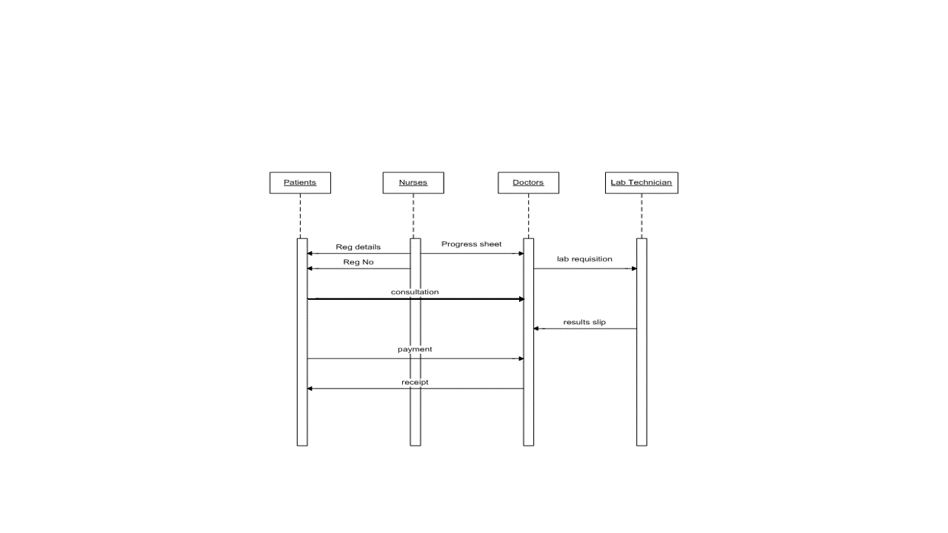

## 4.1.1.1Proposed System

‘l’igure : Proposed System Sequence Diagram

### 

### 4.1.2Conceptual Entity Relational model

Patient

Nurses

Consultatioon

1: M

1: M

1: M

1: M

1: M

Labsreqs

Payment

Doctors

Figure : Conceptual ERM

### 4.1.3Use case model

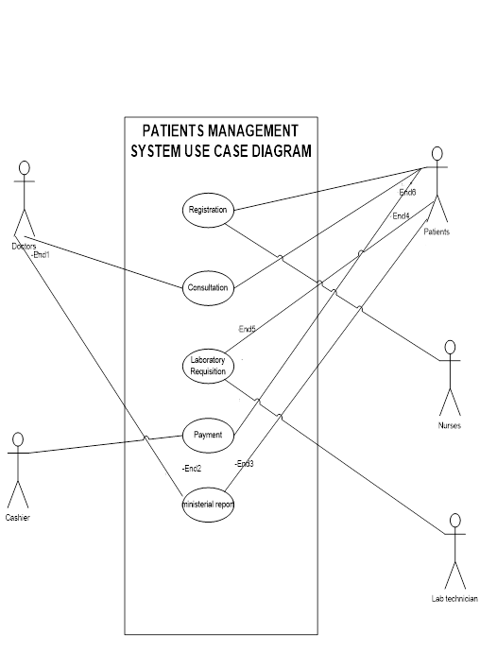

Figure : A use case model

Use case diagrams are used to depict a general overview of the flow of activities of the system

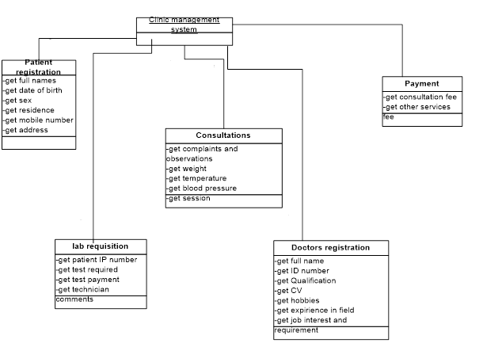

## 4.1.4Class diagram



Figure : System Class Diagram

## 4.1.5Final ERD and database schema

## 4.2PHYSICAL DESIGN

### 4.2.1 Database schema



Table : Database schema

## Input/output screen designs

* 1. **The Patient Registration module**

Residence

Telephone

Address

Gender

Date of birth

FUll Names

Registration No

ID Number

Save

Update

Cancel

Figure : Patient Registration

The Patients Registration module enables for the registration of new patients into the system.

The Patients Registration module enables for the registration of new patients into the system.

The update button allows one to change patient details after he has been registered. It only alters the patient row and not make a new record.

* 1. **Doctors Registration**

Full Names

qualification

Job interest

Telephone



Presented CV

Strength and weakness

Date

Presented CV

Figure : Doctors Registration Screen

Cancel

Update

Register

**This** module allows the doctor to register and the system will automatically generate a doctors number for the doctor. The doctors number is a unique primary key and each doctor will have his own.

The update button allows one to change Doctors details after he has been registered. It only ulters the Doctors row and not make a new record.

* 1. **Lab Requisition**

The Lab Requisition module allows the doctor to ask for a test. Once he/she fills in the details for the test he wants done he/she sends it to the lab. The lab technician finds it as a pop up menu and also can retrieve the tests ordered for from the database.

A doctor can ask for more than test.

Name

Patient Number



Specimens



Test Required

Doctors Number

Date

Delete

Send to lab

Figure :Lab Requisition Module

* 1. **Reports Generator module**

Patients

Consultations

Lab Reqs

Payments

Exit

Print

Figure : Reports Module Screen

Thereport generator module allows one to print a report of the details saved in the database in either a table or a text area.

It will print it in a Adobe Pdf, Word Document, One Note 2007 and Microsoft XPS document creator.

**5.5 The login module**

The log in module allows the registered staff members to login to the system. Each staff member has is own username and password. The nurse cannot login to the consultation or payment module as she/he are only allowed to register patients. The cashier can only login to the payment module. The lab technician can only login to the lab requisition module. The doctor can login to the consultation module and the report generator module.

Cancel

Login

Password

Username

Figure : Login Module Screen

# Implementation & Testing

## 6.1 Description of development Environment/tools

### Programming tools

I chose to work with Java. The tool is quite powerful and flexible. Due to its object oriented nature, it provided for code re-use which saved a good deal of time since the development period was very limited.

The system was executed

### Database tools

MySQL 5 was used due to its high performance, in addition to it being a relational database tool. Small bits of the SQL code were used in the application.

## 7.0 Sample Test Data & Error Handling

### 7.1 Wrong Password Inputs

If a staff member logs into the system and he/she inputs a wrong user name or password the staff member will get an error message asking him/her to input again as shown below.

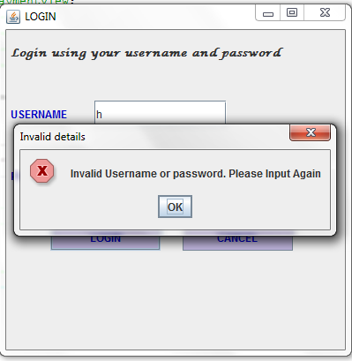

Figure : Access Denied! User privileges

### 

### 7.2 Form Validate

When the nurse is entering patient details, in case he/she fails to fill one field the application gives a notification to the user to fill the fields first before proceeding.

Figure : A partially filled form

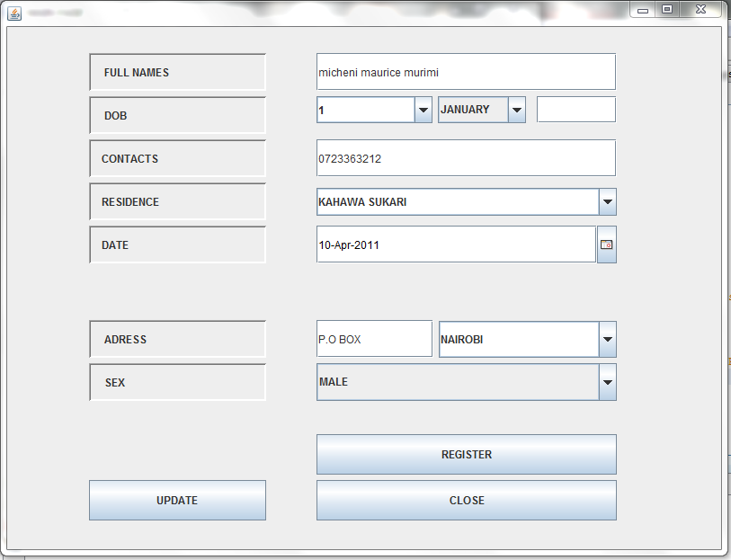

The above form has not been fully filled. The form validator is prompted and a pop up message box appears asking the user to fill all fields before saving the records. The pop up message box is shown below.

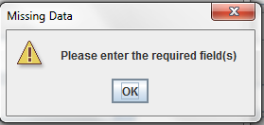

Figure : Form validation in action

## 7.3Appendices

I’m a student of Jomo Kenyatta University of Agriculture and Technology, Department of Information Technology and main campus-Juja and presently doing a project on “Implementing security in health System”. I request you to kindly fill the questionnaires below and assure you that the data generated shall kept confidential.

**PART A**

**Please answer the questions on the basis of your personal opinions, experience or professionalism and without altering the reality of the issue in question.**

1. What are the objectives of the health clinic?

……………………………………………………………………………………….

1. What is the average number of patients that the clinic receives on daily basis?

…………………………………………………………………………………….

1. Other than booking what are other services offered by the clinic?

…………………………………………………………………………………

1. Describe the organizational structure of the health clinic

…………………………………………………………………………………….

1. Describe the current management system in use in terms of its performance?

…………………………………………………………………………………….

1. What are the major shortcomings with the current health system?

………………………………………………………………………………………

1. What outputs are needed at the management level and how are the outputs obtained?

....................................…………………………………………………………….

**PART B.**

1. How would you describe the current system? (Tick one)

* Easy to work with
* Complex
* Relatively easy
* No idea/cannot describe

2. Do you like the current system? (Tick one)

* Yes
* No
* moderately

3. Can you rate the efficiency of the current system? (Tick one)

* 20-40% efficient
* 41-60% efficient
* 61-80% efficient
* 81-95% efficient

4. Would you like an upgrade of the current system? (Tick one)

* Yes
* No
* Moderately

5. What type of system is used in the health clinic? (Tick one)

* Computerized system
* Manual system

6. Which kind of system you would like developed (Tick one)

* Distributed
* Full computerized
* Partially computerized

7. How fast is the current system in processing reports used by the company?

* fast
* moderate
* slow
* very slow